Lab Report

Date: May 4th , 2026
Team: E1
Team Members
Last name | First name | Email
Rahman | Md Mahbubur | md-mahbubur.rahman@stud.hshl.de
Sakib | Md Naimur Rahaman | md-naimur-rahaman.sakib@stud.hshl.de
Xu | Yongyu | yongyu.xu@stud.hshl.de
Koluacik | Baris | baris.koluacik@stud.hshl.de

Goal
Print the 3D modelled holders, assemble them with their corresponding components, check for a proper fit, and make any final adjustments.
Discussion
- IR-Sensors Holders
Modification:The original design called for placing a square ring over the sensor, as shown in Figure 1. Dr.Gido provided feedback so we could save printing time. The IR-Sensors Holders were modified, as shown in Figure 2.
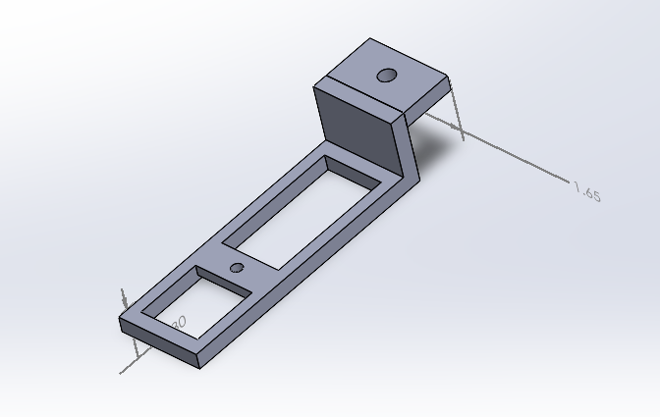
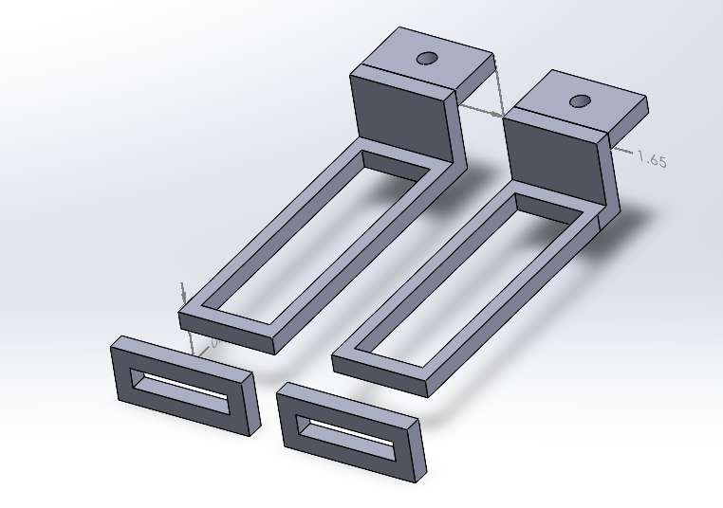
Figure 2 latest design of IR-Sensors Holder
Figure 1 original design of IR-Sensors Holder

- Ultrasonic-Sensors Holders
Problem: The structure is too fragile to be used, as shown in Figure 3.
Solution: A redesign is required, as shown in Figure 4.
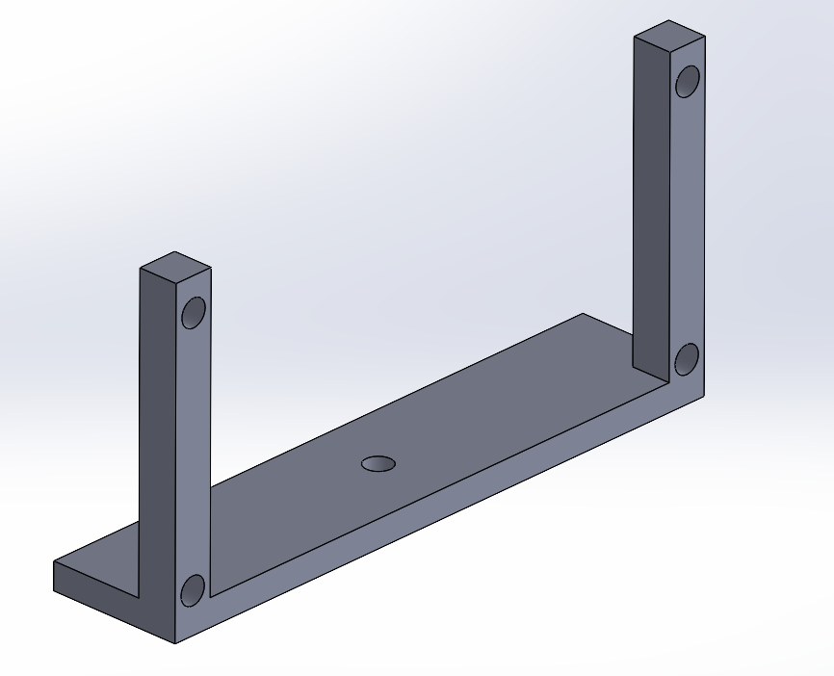
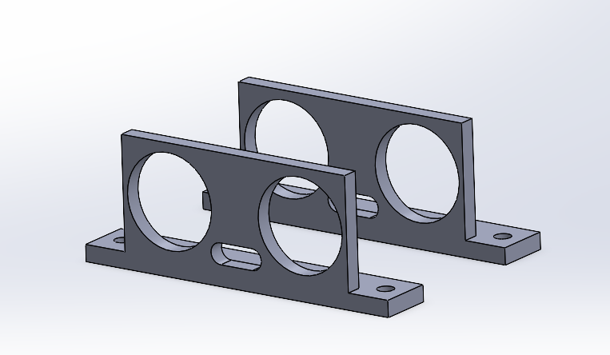
Figure 4 latest design of Ultrasonic-Sensors Holder

Figure 3 original design of Ultrasonic-Sensors Holder

- Motors Holders
Problem: The motor cannot be secured while the wheel is rotating, as shown in Figure 5.
Solution: A redesign is required, as shown in Figure 6.

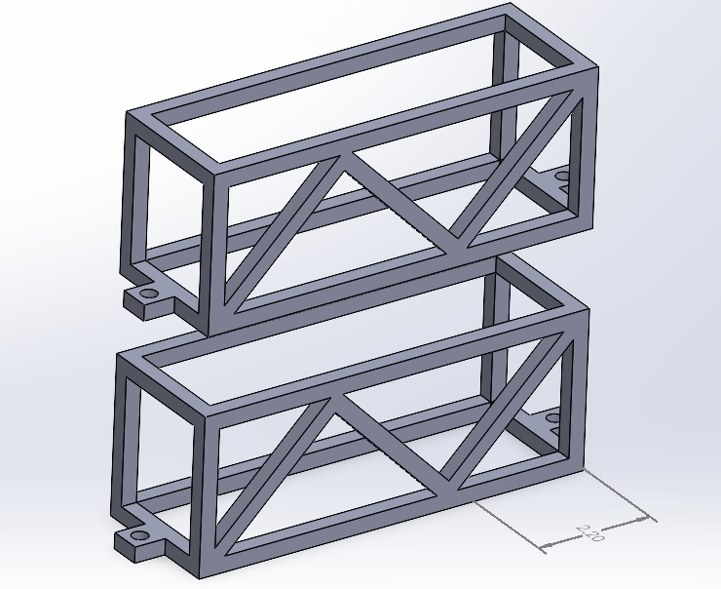
Figure 5: original design of Motors Holders

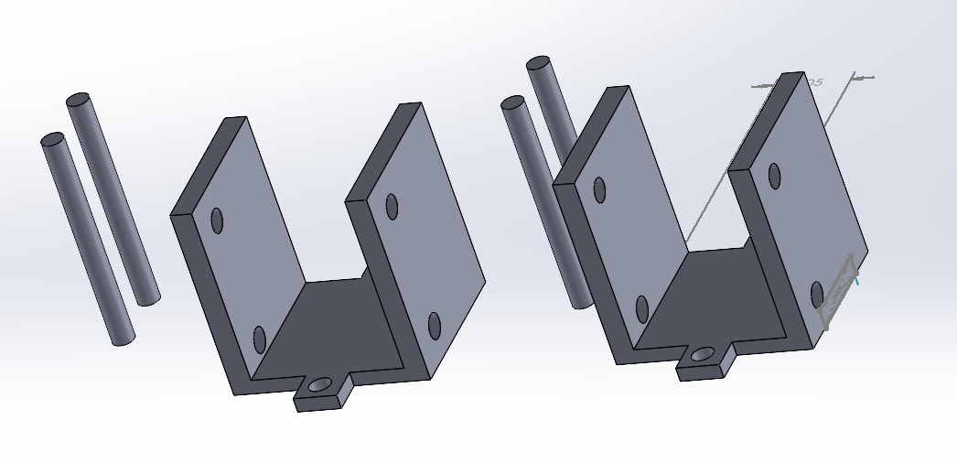
Figure 6: latest design of Motors Holders

- Battery Holder
Problem: Printing time exceeds the specified limit, as shown in Figure 7.
Solution: A redesign is required, as shown in Figure 8.
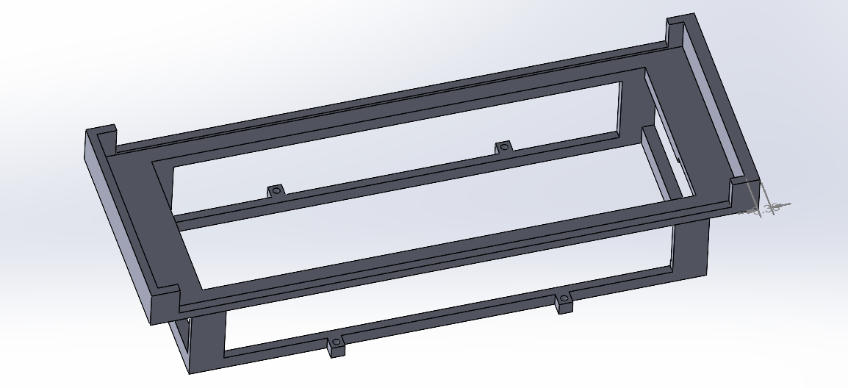
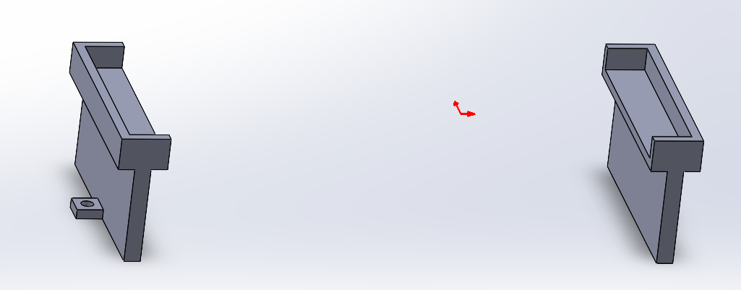
Figure 7: original design of Battery Holder
Figure 8: latest design of Battery Holder

Result
All four holders were 3D printed, assembled with their corresponding parts, and made final adjustment. The specific files have been uploaded to GitHub.

